Team 9

Little Guardian

Contributions
Anthonio Torres: In the report, I put together the text and tables for the testing section of the report. I also formatted the report and assisted with the user manual
Dominik Kornak: Put together the whole Final Design section, and the Risk Analysis section. Also helped put together the User Manual.
Julian Pelayo: Assisted with reviewing the bill of materials, including identifying pricing discrepancies in component costs.
Alfonso Naula: In the report, I contributed with the results from the survey, as well as the Engineering requirements and Product Cost.
Zhixian Yin: In the report, I provided data for wearable part testing, including heart rate and blood oxygen level.

Acknowledgements
Faculty Advisor: Zhao Zhang
Industry Advisor: Syeda Afifa Nadeem
Professor: Mathew Paul Alonso
TA: Deepika Aggrawal
UIC Makerspace
UIC Senior Design Lab Staff
Table Of Contents
Abstract 2
Overview 3
Project Goals 3
Needs Statement 3
Objective Statement 4
Background 4
Research Survey 4
User Survey Report 8
Marketing Requirements 9
Objective Tree 10
Fig. 1. Child Monitor Objective Tree with Weights 11
Engineering Requirements 11
Table I: Engineering Requirements and Justifications 11
Engineering Design Alternatives 14
Design Alternative 1: Combined Oxygen and Heartrate Sensor 14
Fig. 2. Combined 02 and Heartrate Sensor Diagram 15
Table II: I/O For a Combined 02 and Heartrate System 15
Design Alternative 2: Separate Oxygen and Heartrate Sensor 16
Fig. 3. Separate O2 and Heartrate Sensor Diagram 16
Table III: I/O For a Separate 02 and Heartrate Sensor System 16
Design Alternative 3: Gyroscope Positioning Device 17
Fig. 4. Gyroscope Positioning Diagram 17
Table IV: I/O For System with Gyroscope Body Positioning 18
Table V: System Configuration for Sensor Integration 18
Design Alternatives Evaluation Criteria 20
Selection of Design Alternative and Justification 20
Table VI: Decision Matrix 21
Preliminary Design 21
Fig. 5. Level 1 Design for Monitoring System 22
Table VII: Design Element Specifications 22
Circuit Design 23
Fig. 6. Circuit Design 23
Software Design 23
Fig. 7. High-Level Design 24
Fig. 8. Training Subroutine 24
Fig. 9. Camera Subroutine 25
Fig. 10. ESP32 TinyPICO Subroutine 25
Fig. 11. App Subroutine 26
Product Cost and Analysis Budget 26
Table VIII: Budget of parts. 26
Table IX: Estimated Design and Production Costs 27
Testing 27
Unit Testing 28
Integration Testing 28
Acceptance Testing 29
Table X: Heart Rate and Blood Oxygen Measure of Error 29
Table XI: Body Temperature Measure of Error 30
Table XII: Machine Learning Predictability Results 31
Figure 12: System Shutdown Screenshot from Exceed Temperature 32
Table XIII: Summary of Acceptance Tests and Engineering Requirements 33
Risk Analysis 33
Final Design 34
Bill of Materials 36
Contribution Of Work 36
Conclusion 38
References 39
Appendices 42
Appendix A: User Survey Results 43
Appendix B: Technical Engineering Standards 45
Appendix C: Concept Map 46
Appendix D: Decision Matrix Pairwise Comparisons 48
Appendix E: Datasheets for Parts 50
Appendix F: User Manual 51
Appendix G: Lessons Learned 52
Appendix H: Task Allocation and Timeline 53
Appendix I: Images of Final prototype and UI 56
Appendix J: Testing Sheets 58

Abstract
SIDS, sudden infant death syndrome, is an occurrence where a child suffers death while sleeping. There is not one exact reason that SIDS occurs, and instead it can be caused by various factors including asphyxiation, genetic disorders or overheating. As a means to a solution, our team is developing a device that will monitor and display health biometrics of the infant to the user using various microcontrollers, sensors, a camera, and machine learning. Current child monitoring devices are unaffordable, and the devices that are affordable have limited functionality. The product we aim to make will be accurate, cost-efficient, and will have sufficient battery life to last a full night to satisfy our user needs.

Overview
Our project, the child monitoring system, uses a variety of technology such as sensors and cameras to accurately and safely monitor an infant's sleep. With parents worrying endlessly about their children, we implement a device that controls this fear.

Project Goals
Our goal for this project is to develop a child monitoring system that tracks a baby's sleep while achieving comfort, accuracy, and affordability. The monitoring system will track the baby's sleeping position, making sure they are lying safely, as well as measuring oxygen levels, heart rate, and body temperature. The wearable monitor will be made from safe, baby-friendly materials, designed to protect the baby. It will also have a proper heat management system, which will ensure it never overheats, prevents faults, and keeps the baby safe from burns. Lastly, we will offer different packages. This will help reduce costs for families who may not need the full package by allowing the wearable device to be purchased separately, without the camera. An accompanying app will work with the system, displaying all collected data and sending alerts if any issues arise.

Needs Statement
SIDS stands for sudden infant death syndrome and is an occurrence where an infant dies unexpectedly and without known reason, even after an autopsy. The National Institute of Child health and Human Development say that “SIDS is the leading cause of death among infants between 1 month and 1 year of age [1]”. For SIDS to be the cause of death, the cause of death must be unknown. However, publications by Pediatrics in 1994 found that “a rapid decline in prone sleeping also had reductions of approximately 50% [2]” in SIDS rates. This means that although the exact reason of death is unknown, there are still preventative methods surrounding safe sleep that we can utilize to reduce rates of SIDS and infant death even further. Furthermore, there is a need for a device that can monitor an infant's sleep position and health metrics.

Objective Statement
The objective of this project is to create a device that can monitor a child's position and vitals while they sleep. The device must be able to accurately provide various health metrics including oxygen levels, heart rate, and body temperature to a guardian device. This device should also notify the guardian if a child is in a dangerous sleep position or the metrics are abnormal. Devices currently on the market are costly, uncomfortable for the child, or give false alerts. Our product aims to provide accurate monitoring data using this device, while providing affordability and comfortability.

Background
We researched a variety of competitors and systems on the market as well as the need for our project in SIDS. Our findings have been summarized in the sections that follow.

Research Survey
According to statistics provided in 2010 by the U.S. Department of Health and Human Services written by an author named Mathew, “The postneonatal mortality rate declined 5%, from 2.21 to 2.10 deaths from age 28 days to under age 1 year per 1,000 live births [3]”. This means that in total after a baby is born 2 out of every 1,000 babies are likely to pass away before they age a year. There are many reasons as to why these deaths occur. One of the reasons presented by the author Mathew was that the issue may be marital status. In the article it states, “In 2010, the mortality rate for the infants of unmarried mothers was 8.28 per 1,000, 77% higher than the rate for infants of married mothers [3]”. This means that chances increase drastically based on the number of parents or guardians watching the baby. If the baby unfortunately does not have a father to also provide support, then there is a higher chance at some point the baby will not get the attention it needs. Additionally, according to an overview written by Mayo Clinic, “The cause of SIDS is unknown, but it may be caused by problems in the area of an infant's brain that controls breathing and waking up from sleep [4]”. The Mayo Clinic’s research stems from the idea that SIDS can start from the brain. If a baby is put to sleep and is not positioned on its back the chances of SIDS increases. If a baby was born prematurely then the brain wasn’t fully developed which can give the baby less control over their breathing and heart rate. Also, if the mother gave birth before the age of 20, drank or smoked during pregnancy, or did not receive good medical care while pregnant. There are many factors that come into play on how healthy the baby’s brain is, Mayo Clinic provided ways the baby might get SIDS.
Furthermore, according to an article written by Sleep Foundation, “As of 2020, SIDS deaths per 100,000 live births has fallen to 38 [5]”. This article describes one of the key outlines as to why the number of deaths due to SIDS has been dropping is from safe sleep protocols. The highest chance for a newborn 28 days old to a year old to experience SIDS is in their sleep. If, however, the caregiver places the baby to sleep on his back in a soft bedding crib then the chances drop greatly. After the baby has turned a year old then it should be safe for the baby to sleep in any position they want.
Lastly, according to an article written by the Cleveland Clinic, “About 2,500 infants die every year because of SIDS [6]. Risk factors can be smoking around the baby, late or no prenatal care, unsafe sleep positioning or sleeping environment, teen pregnancy, low birth weight, overheating, born male, being a twin, and being a sibling to SIDS victims. These risks can affect the way a baby regulates their breathing, heart rate, and body temperature in which then leads to SIDS.
Currently, there are a few companies making products like our idea. These companies are called Owlet, Sense-U, Nanit and MIKU.
The product Owlet created is called the Owlet Dream Sock. The way it works is that it is almost like a sock, but when placed on a baby's foot it then relays the baby’s heart, sleeping trends, and oxygen readings to the Owlet Dream app. From here the guardian can keep track on the baby’s even when they aren’t with it. Also, this product comes with a bedside base station that glows green when the baby’s health is good and glows red when it receives abnormal readings. The Owlet Dream app also sends notifications to the user when the dream sock receives abnormal readings. The Owlet company made sure to get multiple patents of this product. The patent names are: Wireless infant health monitor, Fetal heart rate extraction within a processor constrained environment, Infant monitoring device (The Dream Sock) [7].
Sense-U created a device that instead of having to put a sock on the baby, it is clipped on to the baby’s diaper or pants. This device tracks the baby’s breathing movement, sleep position, and body temperature. Similar to the Owlet Dreams Sock, this device relays its information to an app called Sense-U Baby with audible alerts. A feature on this device is that if it detects no movement on the baby’s abdomen for 15 seconds it will buzz to try to get a reaction out of the baby to ensure everything is going great. If still no movement is detected, or if the baby is sleeping on the baby’s stomach, then the user of the app will then receive a notification. Similar to the Owlet Dream Sock, this product also has a base station which can send out alerts if it has abnormal readings. The Sense-U has a patent against them. A health technology company named MonDevices owns a patent named, “Method of System of Attachment and Detection of Attachment of a Wearable Sensor to Clothing Material [8]”.
The Nanit created a device that doesn’t need to be attached to the baby. This product is instead a bedside camera that watched the baby. Like an ordinary baby monitor, but different as it monitors a baby’s breathing motion and tracks sleep efficiency. Like the Sense-U Baby and Owlet Dream app, this product also has its own app. In the Nanit app, you can watch your baby, receive notifications such as milestone updates such as for when a baby learns how to sit, and tips on how to take care of the baby. Nanit way of separating itself from the Sense-U and Owlet is by leaving out the heart rate monitor. This way the Nanit doesn’t send continuous alerts that can be classified as false alarms. Nanit’s patents are for the monitoring camera, the monitoring camera and mount, and systems and methods for configuring the baby monitor cameras to provide uniform datasets for analysis and to provide an advantageous viewpoint of babies [9].
MIKU is the company that created MIKU Pro, a premium baby monitor that combines a video camera with advanced non-contact biometric sensing. Unlike traditional monitors that rely only on audio/video or wearable devices, the Miku Pro uses their proprietary “SensorFusion technology” to track a baby’s breathing and sleep patterns in real time without requiring any physical contact, socks, or chest bands. Parents can view live breathing waveforms, sleep quality data, and movement alerts directly in the companion app, alongside standard video and audio monitoring. The system also supports temperature and humidity tracking to give a more complete picture of the baby’s environment. MIKU owns patents named baby monitor, presence and vitals detection of living subject using LWIR and radar systems, system and method for controlling a bedroom environment using a sleep tracking system, living subject identification using image/video discriminator for radar systems, and the method and system for non-invasive detection of a living subject’s blood oxygen saturation [10].
The limitations of my group have include not using a sock as the device we give the baby, we can’t make a product that attaches to clothing, and we can’t make a monitoring camera and mount similar to Nanit. What separates our project from current devices in the market is the design. We are planning on making the device attach to the ankle instead of the foot in hope to provide more comfort. The similarities include heartrate reading, oxygen reading, and body temperature reading. We also plan on making an app to maximize the usefulness of our product.

User Survey Report
The purpose of this survey was to gather information on potential user preferences, expectations and concerns for “little Guardian”. The results are being used to help in product design and development.

Participants: 32 (parents, seniors, potential users).
Data Collection: Online survey (Google Forms).
Format: Multiple choice questions.
Goal: Identify preferred designs, formats and features, usage age range, expected battery life, and budget willingness.

Best Wearable Device
- Bracelet: 50%
- Anklet: 37.5%
- Clip On: 25%
- Sock: 18.8%
- AI Camera: 3.1%
Age Range
- Newborn 12 months: 31.3%
- Newborn 24 months: 34.4%
- Newborn 36 months: 9.4%
- Newborn 48 months: 25%
Current Use of Baby Monitors
- The majority (28.1%) do not currently use one.
- Only 6.3% are using one now.
- Many participants are open to trying one in the future.
Expected Battery Life
- 8 hours: 93.5%
- 6 hours: 6.5%
- 3 hours: 0%
Features Considered Important
- Heart Rate: 87.5%
- Child Temperature: 84.4%
- Oxygen Levels: 78.1%
- Sleep Position: 65.6%
- Room Temperature: 31.3%
- Humidity: 12.5%
- Camera: 3.1%
Budget
- $100–$300: 53.1%
- $50–$100: 37.5%
- Under $50: 9.4%
- Above $300: 0%

Marketing Requirements
As a guideline for what our users require and expect from our device, we developed marketing requirements. These marketing requirements were created with careful consideration of the user survey data and research data that has been collected.
- The system must be comfortable for the child.
- The system must prevent overheating and allow heat to disperse.
- The system materials must be bite-proof.
- The system materials must be free of harmful chemicals.
- The system must accurately detect the child’s body position.
- The system must include an oxygen sensor with accurate readings.
- The system must include a heart rate sensor with accurate readings.
- The system must measure body temperature accurately.
- The system must be affordable compared to similar monitoring products.
- The systems app must be easy to use and notify users accurately.

Objective Tree
The objective tree was created to show our requirements for the baby monitor. We concluded that our top 3 priorities are comfort, accuracy, and affordability.

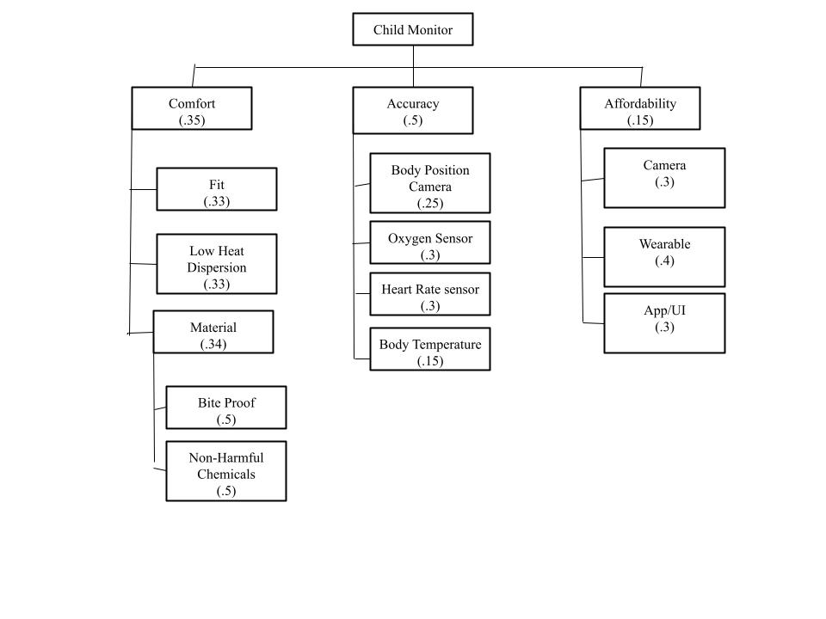

Fig. 1. Child Monitor Objective Tree with Weights

Engineering Requirements
Our engineering requirements will be directly based on our marketing requirements. We expect to create requirements that will provide more specification and be guided by current industry standards. Below is a collection of our requirements.

Table I: Engineering Requirements and Justifications
Marketing Requirement | Requirement Categories | Engineering Requirements | Justification
1,2,3,4 | - Health and Safety  - Legal  - Maintainability  - Social and Cultural  - Political | 1. The wearable device will be encased in food grade silicon | The material used must be safe, comfortable, and durable. There is a risk the baby may bite into the wearable, so we expect it to be food grade silicon. Guiding standard is ISO 10993-1:3018 mentioning device material safeness on skin [11].
6,7,8 | - Functionality  - Performance  - Operational  - Reliability & Availability | 2. The sensors must detect O2 heart rate and body temperature with 95% accuracy or more | One of the main components will be the sensor readings, so these have to be very accurate. However, 100% accuracy would be too straining for our budget. The guiding standard is IEEE 2700-2014 which gives guidance on testing sensor accuracy and comparing performances [12].
5 | - Functionality  - Performance  - Operational  - Reliability & Availability | 3. The camera must detect if the infant is laying on their back, side or belly with an accuracy of 75% using the system setup details provided in the manual | This camera must be accurate, so we expect it to have a 75% accuracy at monitoring sleep positions. The Guiding standard is ISO 5725-1:2023, a standard that can help determine and evaluate the accuracy of a system [13].
1, 2, 8 | - Health & Safety  - Legal  - Operational | 4. The device should auto shutoff if device internal temperature reaches a temperature of 108F | Device overheating can cause irritability and burns. To avoid this issue, the device must have an auto shutoff at 108F. The guiding standard for this requirement is [14] providing recommendations for thermal evaluation of insulating materials.
9,10 | -Economic  - Manufacturability | 5. The total production cost cannot go over $120. | If the production cost isn't managed, then it may exceed the 120$ manufacturing limit. The guiding standard is ASTM E2516-11, which defines a consistent approach for categorizing and managing cost estimates [15].
10,11 | - Usability  - Functionality | 6. The wireless connection with the modules should have at least 200 feet of range in open space (no walls/obstacles) | This device should work within a home and therefore should be able to communicate data between rooms. The guiding standard is IEEE 802.11-2014 which is a standard that defines specifications for wireless connectivity to a station [16].
5, 6, 7, 8 | - Performance  - Energy/Power  - Reliability & Availability | 7. The device should have a battery life of at least 12 hours | If the battery life is unable to last a full night, then data will not be available or accurate. The guiding standard is IEC 62133-2:2017, involving the standard for alkaline batteries [17].
Marketing Requirements:
- The system must be comfortable for the child.
- The system must prevent overheating and allow heat to disperse.
- The system materials must be bite-proof.
- The system materials must be free of harmful chemicals.
- The system must accurately detect the child’s body position.
- The system must include an oxygen sensor with accurate readings.
- The system must include a heart rate sensor with accurate reading.
- The system must measure body temperature accurately.
- The system must be affordable compared to similar monitoring products.
- The system must be able to sell camera and wearable together or separately and be compatible.
- The systems app must be easy to use and notify users accurately.
Non-Requirement Categories:
- Environmental- Our device is expected to be reliable, and so we wouldn’t expect a need to recycle or dispose of these devices often. Also, the wearable should be low power, therefore not contributing to high energy usage.

Engineering Design Alternatives
In this section we will introduce our level 0 design options that have been developed based on our engineering requirements, objective tree, and concept map [appendix B]. Below is a list of our design alternatives and their I/O properties.

Design Alternative 1: Combined Oxygen and Heartrate Sensor
The system provides a comprehensive monitoring solution by combining the O2 and heart rate sensor into one to compute both values. This reduces costs by combining two sensors. The system fulfills the established engineering requirements particularly in key areas such as energy/power, performance, and cost manufacturability. (Engineering requirements [1], [2], [6], [7], [8], [10]). Fig. 2. and Table II below organizes the inputs and outputs of the design. For simplicity, Biometrics data includes signals from a temperature sensor and a combined heartrate/o2 sensor.

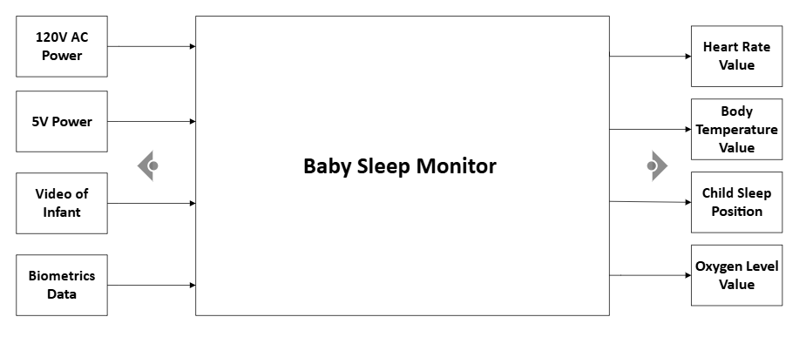Fig. 2. Combined 02 and Heartrate Sensor Diagram

Table II: I/O For a Combined 02 and Heartrate System
Inputs | - Biometrics  - Combined Heartrate/o2 Sensor  - Temperature Sensor  - Video of Infant  - 120V  - 5V DC
Outputs | - Heartrate  - Oxygen level  - Body Temperature  - Sleep Position  - Back  - Front  - Side
Functionality | This device will utilize biometric data and video of the infant, process it, and then display the sleep position and health data on an infant. Health data should be displayed on an app and include body temperature, heart rate, and oxygen levels.

Design Alternative 2: Separate Oxygen and Heartrate Sensor
This system will be like that of figure 3, except instead of using a combined oxygen and heart rate sensor. This system will use two separate sensors for each operation. The system has been verified to satisfy all critical engineering requirements, especially performance and operational requirements. (Engineering requirements [5],[6],[7],[8],[10]). Fig. 3. and Table III below organizes the inputs and outputs of the design. For simplicity, Biometrics data includes signals from a temperature sensor, oxygen sensor, and heartrate sensor.

Fig. 3. Separate O2 and Heartrate Sensor Diagram

Table III: I/O For a Separate 02 and Heartrate Sensor System
Inputs | - Biometrics  - Heartrate Sensor  - o2 Sensor  - Temperature Sensor  - Video of Infant  - 120V  - 5V DC
Outputs | - Heartrate  - Oxygen level  - Body Temperature  - Sleep Position  - Back  - Front  - Side
Functionality | This device will utilize biometric data and video of the infant, process it, and then display the sleep position and health data on an infant. Health data should be displayed on an app and include body temperature, heart rate, and oxygen levels.

Design Alternative 3: Gyroscope Positioning Device
This version removes the camera module entirely along with the second microcontroller. The gyroscope is used in the wearable to determine the position of the child. This will simplify the system to focus entirely on wearable designs. It also mitigates the use of AC power. The system fulfills the established engineering requirements particularly in Operational, reliability, manufacturability cost, usability and performance requirements. (Engineering requirements [5],[6],[7],[8],[9]). Fig. 4. and Table IV below organizes the inputs and outputs of the design. For simplicity, Biometrics data includes signals from a temperature sensor and a combined heartrate/o2 sensor.

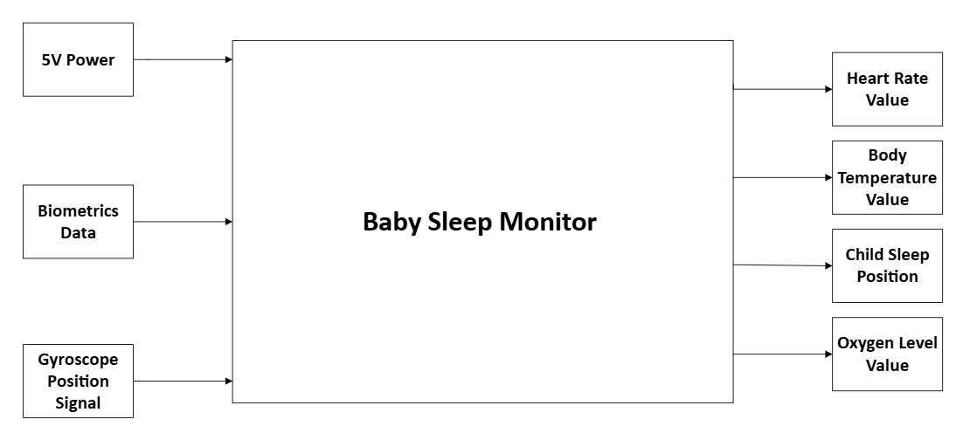Fig. 4. Gyroscope Positioning Diagram

Table IV: I/O For System with Gyroscope Body Positioning
Inputs | - Biometrics  - Heartrate/02 Sensor  - Temperature Sensor  - 5V DC  - Gyroscope Position Signal
Outputs | - Heartrate  - Oxygen level  - Body Temperature  - Sleep Position  - Back  - Front  - Side
Functionality | This device will utilize biometric data and a gyroscope signal, process it, and then provide sleep position and health data on an infant. Sleep signals will be found using the gyroscope signal. Health data should be displayed on an app and include body temperature, heart rate, and oxygen levels.

Table V: System Configuration for Sensor Integration
 | Combined 02 and Heartrate Sensors | Separate 02 and Heartrate Sensors | Gyroscope Positioning Device
Power | 120V AC + 5V DC | 120V AC + 5V DC | 5V DC
Microcontroller(s) | 2(Wearable+Camera) | 2(Wearable+Camera) | 1 (Wearable)
Camera | Included | Included | Not Included
Inputs | - 120V AC Power  - 5V Power  - Combined Heartrate and Oxygen Level Signal  - Temperature Signal  - Video of Infant | - 120V AC Power  - 5V Power  - Heartrate Signal  - Temperature Signal  - Oxygen Level Signal  - Video of Infant | - 5V Power  - Heartrate Signal  - Temperature Signal  - Pressure Signal  -Gyroscope Signal
Outputs | - Heart Rate Value  - Body Temperature Value  - Child Sleep Position  - Oxygen Level Value | - Heart Rate Value  - Body Temperature Value  - Child Sleep Position  - Oxygen Level Value | - Heart Rate Value  - Body Temperature Value  - Oxygen Level Value  - Body Position
Functionalities | This device will utilize biometric data and video of the infant, process it, and then display the sleep position and health data on an infant. Health data should be displayed on an app and include body temperature, heart rate, and oxygen levels. | This device will utilize biometric data and video of the infant, process it, and then display the sleep position and health data on an infant. Health data should be displayed on an app and include body temperature, heart rate, and oxygen levels. | This device will utilize biometric data and a gyroscope signal, process it, and then provide sleep position and health data on an infant. Sleep signals will be found utilizing the gyroscope signal. Health data should be displayed on an app and include body temperature, heart rate, and oxygen levels.
Sensor Configuration | Heartrate sensor used to detect heartrate and O2 Level | Heartrate sensor used to detect heartrate and O2 Sensor used to detect O2 level | Heartrate sensor used to detect heartrate and O2 Level
Advantages | More efficient sensing with 2 vitals monitored with 1 sensor | More accurate O2 level with direct sensor | Easier to implement without camera and second microcontroller
Disadvantages | Less accuracy in O2 reading | Extra sensor used (more area, power, connection) | Gyroscope might not be as accurate as Camera

Design Alternatives Evaluation Criteria
In this section, we will introduce the evaluation criteria we find important in our design. These evaluation criteria will guide our design alternative decision making.
Development Cost
For the development of this device, we have been given a very limited budget. Along with this, our design should be inexpensive to build, allowing us to offer an affordable device for consumers and compete with the prices of competitors.
Technical Knowledge
This device must be developed within 15 weeks. For this reason, our technical knowledge about a design alternative and its elements will be crucial so the device can function before our deadline. Choosing a familiar piece of hardware can ease.
Attractiveness on Resume
This system is the final project for our undergraduate college career, so having an attractive design is important. This device should showcase our engineering ability in a resume.
Compliance with Regulations
This device is expected to be worn on an infant. As such, this device must strictly comply with safety regulations before it can be introduced to the market.

Selection of Design Alternative and Justification
This section will go through our decision making for our design selection. We used a decision matrix where we had to first create weight values for each of our evaluation criteria. To do this, each team member rated our evaluation criteria against each other and took the geometric mean. Tables located in appendix C display all the values used in the decision-making process. Each team member's weights were then averaged to get our final weights for our decision matrix. The relevance of a design alternative to a specific evaluation criterion was also weighted, except these values were agreed upon as a team.

Table VI: Decision Matrix
 |  | Alternative 1 | Alternative 2 | Alternative 3
Criteria 2 | 0.10 | 3 | 3.1 | 4
Criteria 3 | 0.31 | 4.4 | 4.2 | 5
Criteria 9 | 0.29 | 5 | 4.8 | 2.8
Criteria 11 | 0.31 | 3.6 | 3.3 | 4
Score |  | 4.19 | 3.99 | 3.96

Decision Matrix Results
From the resulting decision matrix, the highest score came from design alternative 1 being the best option. The reason it performed better is because it achieves a strong balance between cost, technical difficulty, and performance. Since the combined sensor performs two functions in one device, it helps reduce cost and wiring complexity. It also makes the system easier to build within our 15-week timeline, since we need fewer parts and the overall design is simpler to test. Even though the separate-sensor design had slightly higher accuracy, the added cost and complexity made it less practical for our situation. The gyroscope design also scored well, but it did not meet the safety and accuracy needs as strongly as the other two options.

Preliminary Design
After having evaluated all our design alternatives and finding the best alternative, we have elaborated further upon our chosen design alternative. Below can be found our level 1 design. Our device will use a microcontroller for the wearable device which will work with a temperature sensor and a combined heart rate/O2 sensor. This wearable will be powered by a rechargeable 3.7V lithium-ion polymer battery. The camera setup will you use an ESP32 S3 Sense which contains a removable OV2640 camera and will be powered by a standard 5V type C cable.

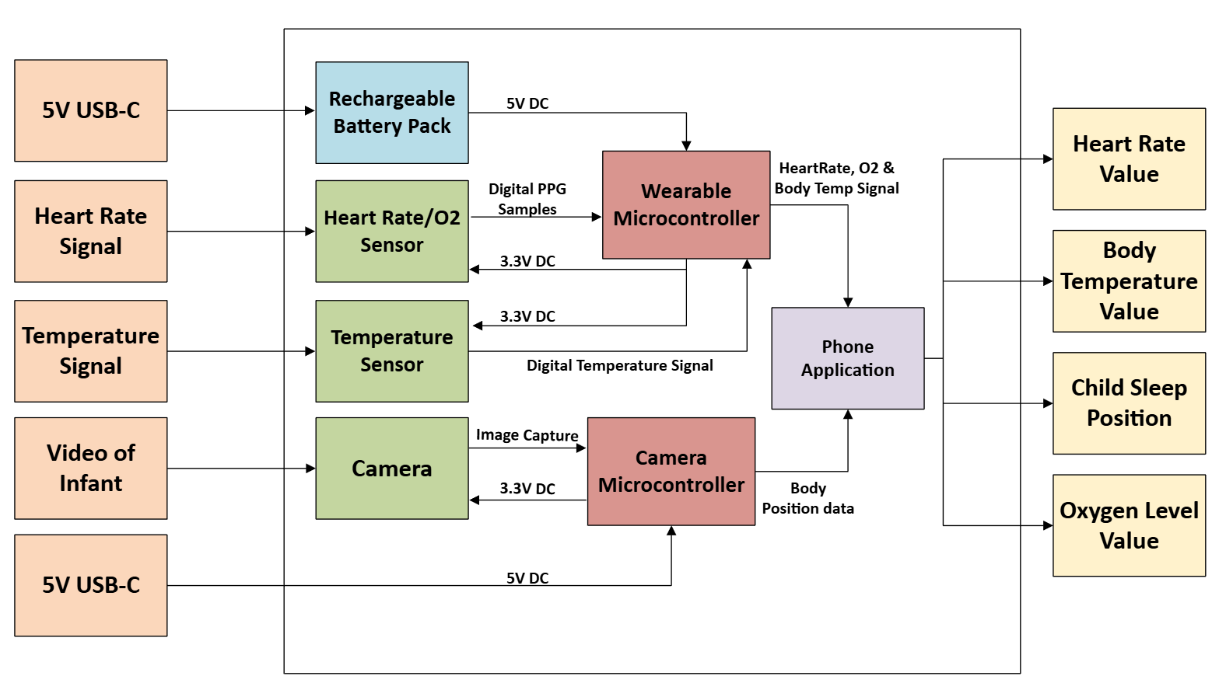Fig. 5. Level 1 Design for Monitoring System

Table VII: Design Element Specifications
Design Element | Part Specification
Wearable Microcontroller | TinyPICO ESP32
Camera Microcontroller | ESP32 S3 Sense
Camera | OV2640
Temperature Sensor | AS6221-AWLT-S WLP LF T&R
Heartrate/O2 Sensor | MAX30102
Rechargeable Battery Pack | LiPo Battery 3.7V 100mAh
Phone Application | Flutter

Circuit Design
This section will outline the system circuit design as well as its system components.

Fig. 6. Circuit Design
Figure 6 shows a TinyPico based wearable system powered by a Li-ion battery, connected to heart rate and temperature sensors. This also has a separate USB powered ESP32 cam module.

Software Design
High-level Design
This diagram shows a system where a CNN model trained with Python is used on an ESP32 CAM for posture detection. A TinyPico ESP32 collects vital sign sensor data, and a flutter app receives and displays outputs from both devices through MQTT.
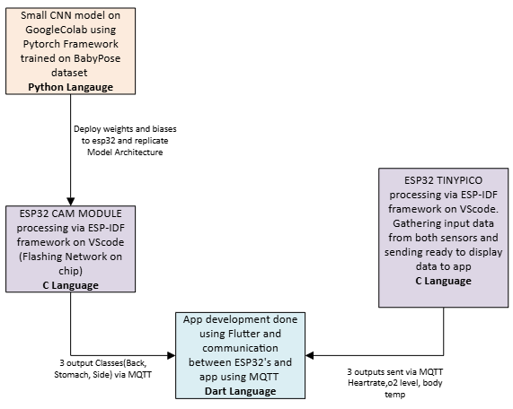

Fig. 7. High-Level Design

Training Subroutine
This diagram shows how the BabyPose dataset and Tiny MobileNetV2 model are trained on Google Colab using PyTorch, producing a small int9-quantized neural network ready to run on the ESP32.s

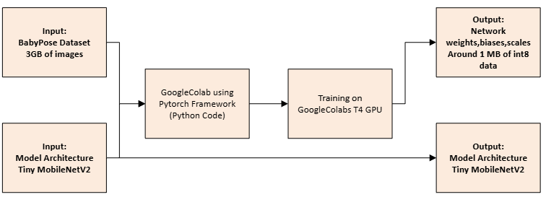Fig. 8. Training Subroutine

ESP32 Camera Subroutine
This diagram shows how the ESP32-CAM runs an onboard Tiny MobileNetV2 model to analyze video frames and classify the baby’s sleep position, sending the result to the app via MQTT.

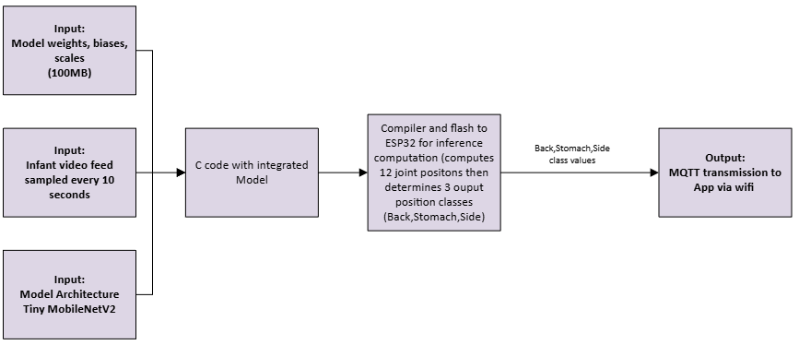Fig. 9. Camera Subroutine

ESP32 TINYPICO Subroutine
This diagram shows how the TinyPico ESP32 reads sensor data through a sensor interface, computes heartrate, oxygen level, and body temperature, and sends the results to the app via MQTT.

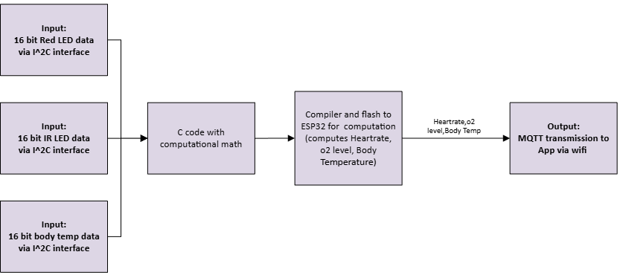Fig. 10. ESP32 TinyPICO Subroutine

App Subroutine
This shows that the app combines posture data and vital sign data retrieved via MQTT, determines if a warning is needed, and displays all measurements with their target ranges.

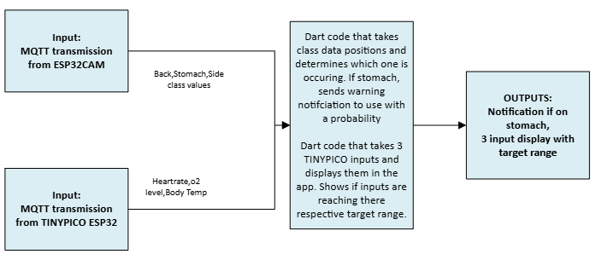Fig. 11. App Subroutine

Product Cost and Analysis Budget

Table VIII: Budget of parts.
Part name | Part Number | Source | Quantity | Cost (shipping and taxes included)
Seeed Studio XIAO ESP32 S3 Sense | XIAO ESP32S3 Sense | Amazon | 1 | $29.42
TinyPICO ESP32 Dev Board | ESP32 | Adafruit | 1 | $29.56
MAX30102 Sensor Module (5 pcs) | MAX30102 | Amazon | 1 | $21.28
AS6221-AWLT-S WLP T&R | AS6221-AWLT-S WLP | DigiKey | 1 | $8.22
HDC1080 Temp/Humidity Sensor | HDC1080DMBR | Digikey | 1 | $9.18
Waterproof Air Tag Wristband | B0C6B5F5CZ | Digikey | 1 | $16.88
Micro-Lipo USB-C Charger | STM32F405 | Adafruit | 1 | $11.36
Total cost: $125.90

Table IX: Estimated Design and Production Costs
Category | Cost Estimate
Electrical Design | $20
Assembly | $15
Tools | $20
Testing | $10
Total Cost: $65
The components in the design contribute differently to the total cost of production effort. The ESP32 boards (XIAO S3 and TinyPICO) require the most integration time due to firmware setup, pin configuration, and communication testing. Sensors such as the MAX30102, AS6221, and HDC1080 add moderate workload because they require calibration and I2C verification, while the wristband involves no electrical integration. The LiPo charger adds assembly and safety testing but does not significantly increase production time. Our total cost of production is $190.90 and based on similar infant monitoring devices on the market, this cost remains reasonably competitive.

Testing
This section will detail the unit, integration, and acceptance testing methods that were designed and implemented while building this device. In addition to this, the acceptance testing results of the device will also be included.

Unit Testing
Unit testing during initial prototype development was done on the Bluetooth communications system, ESP hosted webpage, health biometrics readings, and machine learning deployment. The bluetooth client and server side were each tested using the nRF Connect app to ensure the connection could be established and that data was being properly received or sent before continuing to integration testing. The ESP webpage was tested by utilizing a ESP source code for a basic webpage setup and ensuring it could be accessed on a browser. Health biometric readings were unit tested by developing a ESP-IDF code which would print sensor readings to the console to ensure periodic readings were occurring.

Integration Testing
Integration testing of the BLE communication was completed by programming constantly changing data values to be displayed on the server side. Then, print statements were implemented within both the client and server code to detail when a BLE connection and data transfer occurs between the two ESP devices. Along with this, the nRF Connect app was utilized to ensure the data being transferred and received was accurate. Once successful, the BLE system was integrated and tested with the ESP webpage. In this test, the ESP server was monitored to ensure BLE advertisement and connection occurs while the ESP webpage that had been unit tested was observed as the BLE client display. As values are sent through the server side, it was verified that the values were being accurately displayed on the webpage. Health biometric readings integration testing with the ESP webpage followed the same procedure as the BLE and webpage integration testing method of ensuring data values are properly sent from the client and updated to the webpage.

Acceptance Testing
Heart Rate and blood oxygen accuracy testing was completed by taking data samples from both the Little Guardian system and an Apple Watch concurrently. The percent error between each sample was then calculated and averaged to determine the Mean Absolute Percentage Error. Using this value, a percentage of accuracy was determined. This test was specifically done with prototype readings being taken from the fingertip and not the ankle. Table X presented below organizes the resulting health biometrics values and their corresponding error values.

Table X: Heart Rate and Blood Oxygen Measure of Error
Trial | Reference HR (bpm) | Reference SpO2 (%) | Little Guardian HR (bpm) | Little Guardian SpO2 (%) | Percent Error | Percent Error
1 | 80 | 98 | 80 | 99 | 0.00 | 1.02
2 | 81 | 98 | 83 | 97 | 2.47 | 1.02
3 | 82 | 97 | 83 | 97 | 1.22 | 0.00
4 | 83 | 99 | 82 | 99 | 1.20 | 0.00
5 | 82 | 98 | 81 | 99 | 1.22 | 1.02
6 | 81 | 97 | 81 | 97 | 0.00 | 0.00
7 | 82 | 98 | 81 | 97 | 1.22 | 1.02
8 | 84 | 99 | 84 | 98 | 0.00 | 1.01
9 | 83 | 97 | 83 | 98 | 0.00 | 1.03
10 | 82 | 98 | 82 | 97 | 0.00 | 1.02
11 | 81 | 99 | 79 | 99 | 2.47 | 0.00
12 | 82 | 98 | 83 | 98 | 1.22 | 0.00
13 | 83 | 97 | 84 | 98 | 1.20 | 1.03
14 | 82 | 98 | 82 | 98 | 0.00 | 0.00
15 | 81 | 99 | 81 | 100 | 0.00 | 1.01
16 | 82 | 98 | 84 | 98 | 2.44 | 0.00
Body temperature accuracy was tested in a different form than the heart rate and blood oxygen were tested. However, the same engineering requirement applies, expecting a minimum accuracy of 95%. To determine accuracy, temperature values are recorded from the prototype and a digital thermometer concurrently. These data samples were also taken at the ankle instead of the fingertip to emulate the actual placement of the device. The percentage error between each sample is calculated and then averaged to determine the mean absolute percentage error for body temperature readings. Using this value, a percentage of accuracy was determined for body temperature. Table XI organizes all data samples and their associated percent error. Using the percent errors associated with this section, a percent error of 99.04% was found for the body temperature.

Table XI: Body Temperature Measure of Error
Trial | Control Temperature | Guardian Temperature | Percent Error
1 | 87.6 | 89.7 | 2.40
2 | 87.6 | 89.7 | 2.40
3 | 88.2 | 89.4 | 1.36
4 | 88.3 | 89.7 | 1.59
5 | 88.5 | 89.7 | 1.36
6 | 88.7 | 89.6 | 1.01
7 | 88.9 | 89.6 | 0.79
8 | 88.9 | 89.7 | 0.90
9 | 89.1 | 90.1 | 1.12
10 | 89.2 | 89.9 | 0.78
11 | 89.2 | 89.8 | 0.67
12 | 89.4 | 89.9 | 0.56
13 | 89.6 | 90.2 | 0.67
14 | 89.6 | 90.1 | 0.56
15 | 89.8 | 89.7 | 0.11
16 | 89.8 | 89.9 | 0.11
17 | 90.0 | 90.2 | 0.22
18 | 90.0 | 90.1 | 0.11
19 | 90.1 | 90.1 | 0.00
20 | 90.3 | 90.5 | 0.22
21 | 89.4 | 90.3 | 1.01
22 | 89.6 | 90.3 | 0.78
23 | 89.6 | 90.6 | 1.12
24 | 89.8 | 91.0 | 1.34
25 | 90.0 | 90.8 | 0.89
26 | 90.1 | 91.0 | 1.00
27 | 90.3 | 91.5 | 1.33
28 | 90.3 | 91.5 | 1.33
29 | 90.5 | 91.5 | 1.10
30 | 90.1 | 91.9 | 2.00
The machine learning accuracy was expected to be at a minimum of 75%. The method in which the machine predictability was determined was by utilizing a doll to simulate various sleep positions. The doll was placed in each sleep position, and 10 predictions were taken at each of these sleep positions, back, side, and stomach. The accuracy at each sleep position was determined, and then the total accuracy for machine learning predictability was found by averaging these percentages. From Table XII, side, back, and stomach sleep positions each had an accuracy of 90%, 100%, 80%, respectively. Taking the average of these accuracies establishes a total machine predictability average of 90%. A second accuracy was also found by testing the trained model against a custom data set, resulting in an accuracy of 89.50%.

Table XII: Machine Learning Predictability Results
Sleep Position | Trial | Prediction Result | Position Accuracy | Total System Accuracy
Side | 1 | Correct | 90% | 90%
 | 2 | Correct
 | 3 | Incorrect
 | 4 | Correct
 | 5 | Correct
 | 6 | Correct
 | 7 | Incorrect
 | 8 | Correct
 | 9 | Correct
 | 10 | Correct
Stomach | 1 | Correct | 100%
 | 2 | Correct
 | 3 | Correct
 | 4 | Correct
 | 5 | Correct
 | 6 | Correct
 | 7 | Correct
 | 8 | Correct
 | 9 | Correct
 | 10 | Correct
Back | 1 | Correct | 80%
 | 2 | Incorrect
 | 3 | Correct
 | 4 | Correct
 | 5 | Correct
 | 6 | Correct
 | 7 | Correct
 | 8 | Correct
 | 9 | Correct
 | 10 | Correct
As a safety net, an engineering requirement put in place is that the wearable device should shut down if the body temperature reading is above 108F. To test this scenario, the system is first powered on and set to operate normally. While normal operation is occurring, a heat gun is utilized to apply heat to the wearable device. The ESP-IDF code is implemented to periodically check the body temperature, and it should be observed that this temperature begins to increase from the heat. Once the heat reaches above 108F or 42.00C, the device is expected to shut down by entering a deep sleep mode. From figure 12 below, it cna be seen that during the temperature shutoff test, the system shuts down at a temperature of 42.9C which is approximately 109.2F. This satisfies our expectation of a shutoff occurring when body temperature exceeds 108F.

Figure 12: System Shutdown Screenshot from Exceed Temperature
Acceptance tests for both the battery life and range of connectivity were developed as well. For the battery life acceptance testing, the wearable device is expected to be first fully charged and operating as normal. After verifying the wearable is taking periodic readings and displaying on the webpage, allow the system to run overnight. The webpage host will be implemented with a time record of the time when the wearavle disconnects after it loses charge. The total battery life resulting from this test should be at least 12 hours. The range of connectivity acceptance test requires the device to be operating in an open area. While connected to the webpage on a device, walk away from the camera module until the device loses connection. It is expected that the user should be able to walk at least 200 feet from the camera module before a disconnect occurs. To test this further, the tester may also walk around the camera module at a distance of 200 feet and verify that the system remains connected. Although acceptance tests were designed for these two engineering requirements, they were not successfully tested. However, utilizing expected values of power consumption for the ESP device and the battery capacity, it is estimated that the wearable device has a battery life of at least 13 hours. The range of connectivity was also not tested directly because the Little Guardian device establishes a connection to the webpage via a local router. This means the range of connectivity will likely be 200 feet, but it will also depend on each router.
Table XIII shown below provides a summary of the results of acceptance testing and its correlation to each engineering requirement.

Table XIII: Summary of Acceptance Tests and Engineering Requirements
Acceptance Test Result | Engineering Requirement | Conclusion
Heart rate accuracy results showed 99.08%. Blood oxygen accuracy results showed 99.43%. Body temperature accuracy was 99.04%. | The sensors must detect O2 heart rate and body temperature with 95% accuracy or more | The resulting accuracy for each of the sensor readings was above 99%. This satisfies the engineering requirement set for sensor accuracy of 95%.
Combined machine learning accuracy was 90%. The back sleep position resulted in an accuracy of 80% and was the lowest accuracy. | The camera must detect if the infant is laying on their back, side or belly with an accuracy of 75% using the system setup details provided in the manual | The resulting camera system had a total accuracy above the 75% minimum accuracy required. The lowest sleep position accuracy was also above 75%
Applying heat to the prototype system, the device shuts off at a temperature of 109.22F. | The device should auto shutoff if device internal temperature reaches a temperature of 108F | The prototype accurately shuts off at a temperature above 108F, satisfying the engineering requirement
Estimated at least 13 hours of battery life | The wireless connection with the modules should have at least 200 feet of range in open space (no walls/obstacles) | Utilizing the estimation battery life calculation, the engineering requirement should be satisfied
Depends on each router | The device should have a battery life of at least 12 hours | Routers should successfully allow 200 feet of range however, it may vary.

Risk Analysis
In this section, recognition of possible safety risks or failure points of the system design will be acknowledged. In addition, an analysis will be conducted to determine methods of mitigating the possible occurrence of failure and prevent further damage in the case of a failure.
The first risk we had to consider was the wearable module irritating or harming the baby due to trapped heat or an overheating device. We implemented a temperature shutoff at 108 degrees Fahrenheit, preventing the user from being harmed if the temperature reaches that value.
For the wearable, we also implemented the silicon band, so that if an infant tries to bite and eat the band, it will not consume toxic chemicals that can harm it.
Since our Camera isn’t infrared, we cannot detect infant sleeping position in the dark. If this device is applied in such a scenario, it will fail and not detect the infants' sleeping position.

Final Design
Figure 13: Updated Final Design
Our final design had 5 changes, the first two being the addition of 2 output values, a live camera feed, and a Battery Level value. We decided to implement the live camera feed because a large percentage of current baby monitor users find it necessary, and because it helped us test the camera working correctly. We also implemented the Battery level value due to users needing to know the operating time of the wearable.
Our other two changes came from the user interface application approach we decided on. Previously, we were going to use a mobile app for the user, however, this would be too time-consuming and difficult to implement. Due to this, we followed a local server webpage approach, where the ESP32CAM module would connect to a local Wi-Fi network and host a local webpage to display all outputs for the user. This came with some benefits, where everything is hosted locally, so there is no possibility of a network attack where an attacker can get sensitive data from the application. Also, this approach reduces connectivity to WAN’s, reducing costs with internet usage. Secondly, in the previous design we connected both the Wearable and Camera subsystems to the app. Instead, we connect the Wearable to the Camera module via Bluetooth for data transmission and then connect the Camera module to the local Wi-Fi as mentioned previously. This design was implemented due to the power consumption of Wi-Fi, where we had to meet strict demands on the Wearable because of battery life.
Our final change was the use of a combined heart rate, oxygen level, and temperature sensor. This change was implemented due to the size constraint we had on the Wearable, and the cost efficiency with having an all-in-one sensor. The MAX30102 sensor gave us all three of these vitals, making it the best sensor to utilize.

Bill of Materials
Table XIV: Bill of Materials for Device Production
Part name | Part Number | Source | Quantity | Unit Cost
Seeed Studio XIAO ESP32 S3 Sense CAM | XIAO ESP32S3 Sense CAM | Amazon | 1 | $20.39
Seeed Studio XIAO ESP32 S3 Sense | XIAO ESP32S3 Sense | Amazon | 1 | $16.99
MAX30102 Sensor Module (5 pcs) | MAX30102 | Amazon | 1 | $2.00
Flexxicam Baby Camera Holder | Baby Camera Holder | Amazon | 1 | $16.88
Battery Lith-Ion 3.7V 500mah | 1528-1841-ND | Digikey | 1 | $7.95
LAKSDIURT Silicone Protection Case for Tile Mate | Silicon Protection case | Amazon | 1 | $5.00
Fast Charging 10FT - 20W USB C Charger Block with Type C Cable | CA-43T | Amazon | 2 | $  4.95
ESP32 CAM case | bkgoodman  (3D Print) | UIC Makerspace | 1 | ~$5.00
Total cost: $84.11

Contribution Of Work
Anthonio Torres: In the development of this device, I worked on setting up the Bluetooth communications system. I implemented and tested both the server and client side of the Bluetooth component. Along with this, I assisted in sourcing images to create data sets in which we could use to train and test the machine learning model. I created the second wearable prototype which was a soldered prototype put together on a perf board. This was an improvement in the initial breadboard prototype. I also implemented and tested the temperature shutdown safety feature. My last contribution to the prototype was to test the body temperature accuracy of the wearable device.
Dominik Kornak: In the development of this device, I worked on ESP32 Camera and the Wi-Fi setup. Firstly, I made the decision to gather all of the infant sleep position data, which I had assistance from other teammates. Once I had all this data, I implemented a custom neural network that would best fit this project's goal. I decided on 3 convolutional layers and 3 fully connected layers, with pooling and ReLU in-between to achieve the best memory efficiency and accuracy. I trained the network and deployed all the parameters onto the ESP32CAM for on-device inference. For the ESP side, I first initialized and formatted the camera module and then deployed and implemented the network parameters for the Sleep Position Detection to successfully utilize the camera feed as input. I also implemented the Wi-Fi network setup and local webpage on the ESP32CAM, successfully displaying a fully functioning and interactive webpage for the user to utilize. I tested the sleep detection network on a baby doll and tested the local webpage and Wi-Fi setup on many different Wi-Fi networks.
Julian Pelayo: In the development of this device, I worked on the PCB design using KiCad. I created a full schematic and PCB layout from scratch for a system incorporating the ESP32-S3 and MAX30102 sensor. This included selecting components, routing connections, and ensuring proper integration between the microcontroller and sensor. Although a teammate's PCB design was ultimately used due to its more compact size, my design contributed to validating the circuit and overall hardware functionality. Along with this, I assisted in gathering and organizing image data to create datasets used to train and test the machine learning model.
Zhixian Yin: In this baby monitor project, I mainly contributed to the design and development of the wearable monitoring part. I worked on integrating the MAX30102 sensor to measure the baby’s skin temperature, heart rate and blood oxygen level, and helped improve the signal processing algorithm to obtain more stable and accurate readings. I also participated in testing the wearable device by comparing its results with a smartwatch. Based on valid readings, our system achieved a mean absolute error of 1.00 bpm for heart rate and 0.44% for SpO₂, showing reasonable accuracy for our prototype. In addition, I contributed to the overall system design, including the communication between the wearable device and the camera. I helped evaluate design trade-offs such as cost, power consumption, comfort, safety, and feasibility within our 15-week development timeline. My work helped make the wearable part lightweight, low-power, and suitable for continuous baby monitoring.
Alfonso Naula: I contributed to multiple stages of the PCB development process for the wearable device. First, using KICAD I made different designs for the PCB, starting with the schematic of the two main components ESP32-S3 and MAX30102 sensor. I also created the footprint for the MAX30102 sensor to ensure accurate placement and combability with the PCB layout. I was responsible for assembling and testing the wearable band. This included soldering the electronic components to the PCB, soldering the lithium battery to the ESP32-S3, and verifying that all the components functioned correctly after assembling. I performed tastings to ensure that the sensor and the microcontroller had reliable communication.

Conclusion
To conclude, our implementation of an infant monitoring device was successful. We monitor the infants' sleeping position with a camera and detect how they are sleeping, also monitoring the vitals of an infant with a wearable device, displaying all the given information on a webpage for the user to access. We can improve our design in many ways. Firstly, we can implement an infrared camera that tracks the baby's position at night, being applicable for all times of day. Also, we can completely replace the wearable device and integrate everything onto the camera, letting the infant sleep without anything physically on it, improving overall safety. These improvements would require more research and implementation, which can be done with more time.

References

[1] National Institute of Child Health and Human Development. “Social and Digital Media”. Safe To Sleep. Accessed Oct. 2, 2025. [Online] Available: https://safetosleep.nichd.nih.gov/resources/social-digital .
[2] M. Willinger, H. J. Hoffman, and R. B. Hartford. “Infant Sleep Position and Risk for Sudden Infant Death Syndrome: Report of Meeting Held January 13 and 14, 1994, National institutes of Health, Bethesda, MD”. Article, vol. 93, Issue. 5, May 1994. doi: 10.1542/peds.93.5.814.
[3] Mathews, T. J. and MacDorman, Marian F. "Deaths: Preliminary Data for 2011" vol. 62, no. 8, 2012. Accessed Oct. 2, 2025. [Online] Available: Deaths: Preliminary Data for 2011.
[4] Mayo Clinic. “Sudden infant death syndrome (SIDS)”. Accessed Oct. 2, 2025. [Online] Available: Sudden infant death syndrome (SIDS) - Symptoms and causes - Mayo Clinic
[5] Sleep foundation. “Sudden Infant Death Syndrome (SIDS) and Sleep. Accessed Oct. 2, 2025. [Online] Available: What Is Sudden Infant Death Syndrome (SIDS)? | Sleep Foundation
[6] Cleveland Clinic. “SIDS (Sudden Infant Death Syndrome)”. Accessed Oct. 2, 2025. [Online] Available: SIDS (Sudden Infant Death Syndrome): Causes & Prevention
[7] Patents assigned to Owlet Baby Care, Inc. Accessed Oct. 2, 2025. [Online] Available: Patents Assigned to OWLET BABY CARE, INC. - Justia Patents Search
[8] The complaint Mondevices v. Ledo Network have over their patent against Sense-U. Accessed Oct. 2, 2025. [Online] Available: Mondevices v. Ledo Network - Complaint | PDF | Diversity Jurisdiction | Tort
[9] Patents assigned to Nanit, inc. Accessed Oct. 2, 2025. [Online] Available: Patents | Nanit
[10] Patents assigned to Miku, inc. Accessed Oct. 2, 2025. [Online] Available: Patents Assigned to Miku, Inc. - Justia Patents Search
[11] ISO. ISO 10993-1:2025- Biological Evaluation of Medical Devices. ISO. https://www.iso.org/standard/10993-1 (Accessed October 17, 2025).
[12] IEEE. 2700-2017 – IEEE Standard for Sensor Performance Parameter Definitions. IEEExplore. https://ieeexplore.ieee.org/document/8277147/keywords#keywords
[13] ISO. ISO 5725-1:2023 Accuracy (trueness and precision) of Measurement Methods and Results. ISO. https://www.iso.org/standard/69418.html (Accessed October 17, 2025).
[14] IEEE. P1/D3, Mar 2025- IEEE Draft Recommended Practice for General Principles for Temperature Limits in The Rating of Electrical Equipment and for the Evaluation of Electrical Insulation. IEEExplore. https://ieeexplore.ieee.org/document/11176091 (Accessed October 19, 2025).
[15] ASTM. E2516-11 – Standard Classification for Cost Estimate Classification System. ASTM International. https://www.astm.org/e2516-11.html (Accessed October 19, 2025).
[16] IEEE. 802.11-2024 – IEEE Standard for Information Technology—Telecommunications and Information Exchange Between Systems Local and Metropolitan Area Networks—Specific Requirements Part 11: Wireless LAN Medium Access Control (MAC) and Physical Layer (PHY) Specifications. IEEExplore. https://ieeexplore.ieee.org/
document/10979691. (Accessed November 5, 2025).
[17] IEC. 62133-2:2017 – Secondary Cells and Batteries Containing Alkaline or Other Non-Acid Electrolytes – Safety Requirements for Portable Sealed Secondary Cells, and for Batteries Made from Them, for Use in Portable Applications – Part 2: Lithium Systems. IEC. https://webstore.iec.ch/en/publication/32662 (Accessed October 19, 2025).

Appendices

Appendix A: User Survey Results
The data results below were collected using Google Forms. The survey questions were developed by the team carefully, and the survey was then distributed to parents and pregnant families to receive results from our target audience.

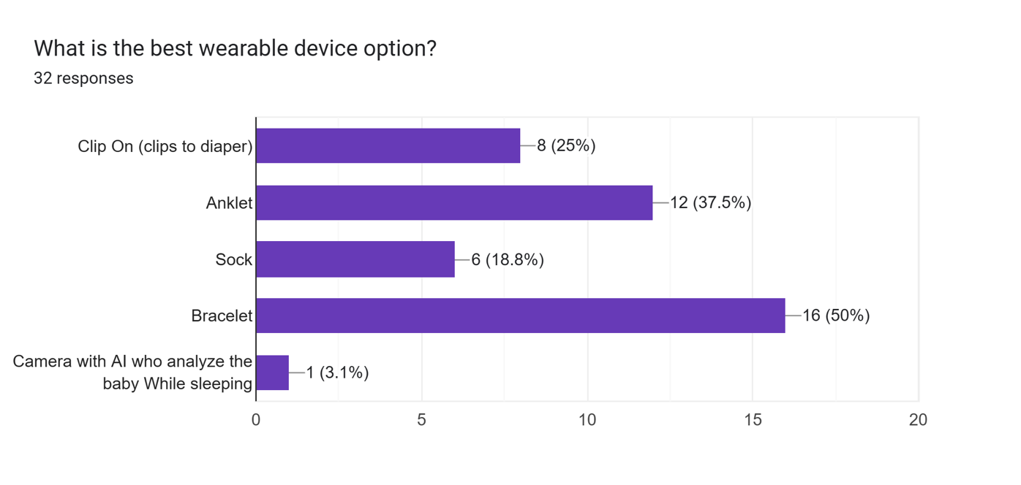
Fig. A1. Best Wearable Device

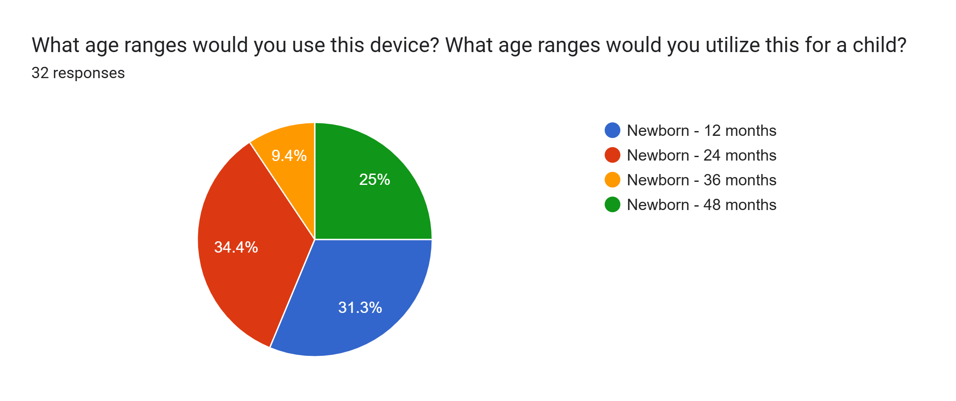
Fig. A2. Age Range

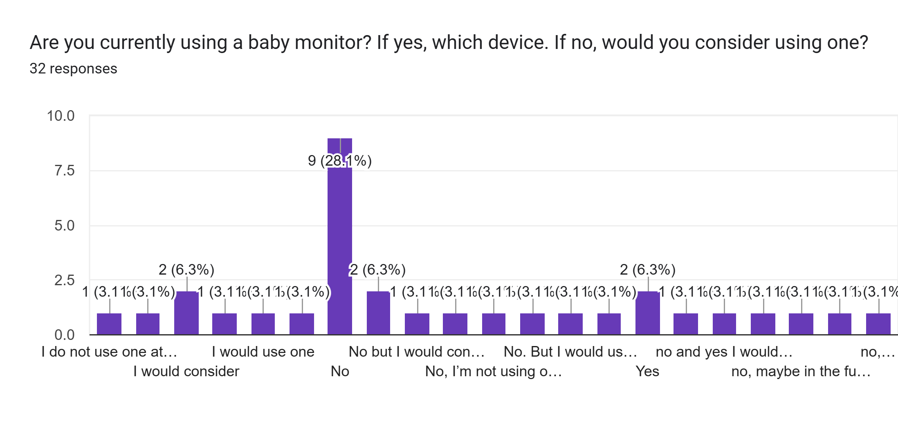
Fig. A3. Current Use of Baby Monitors

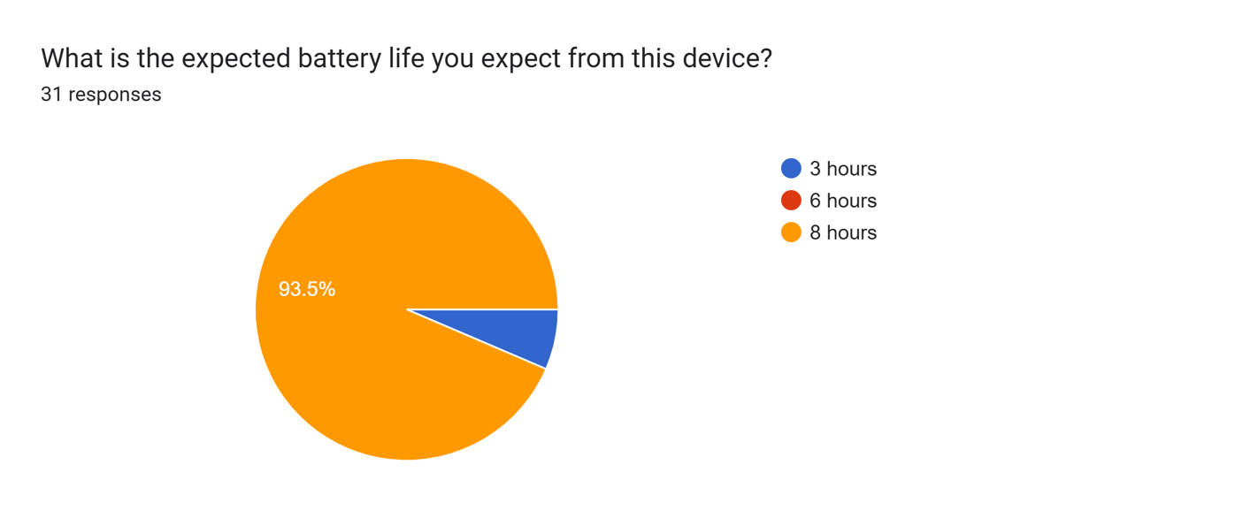
Fig. A4. Expected Battery Life

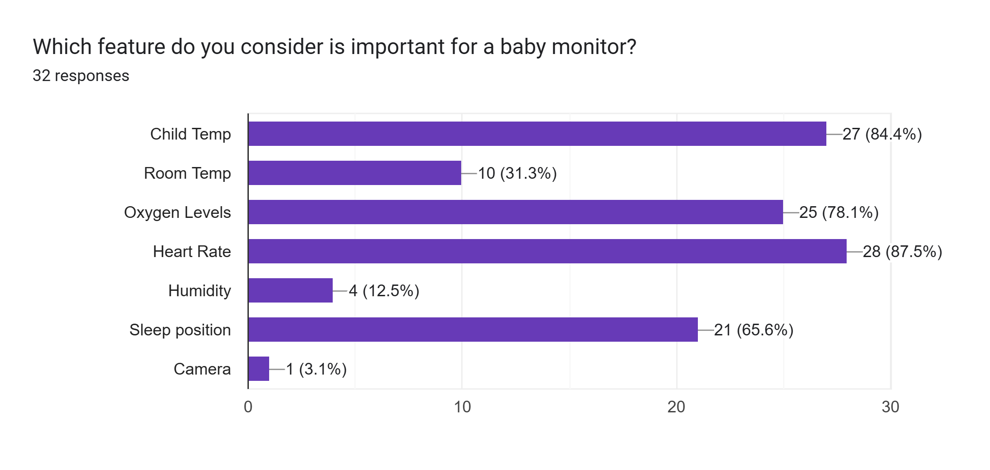
Fig. A5. Best Feature
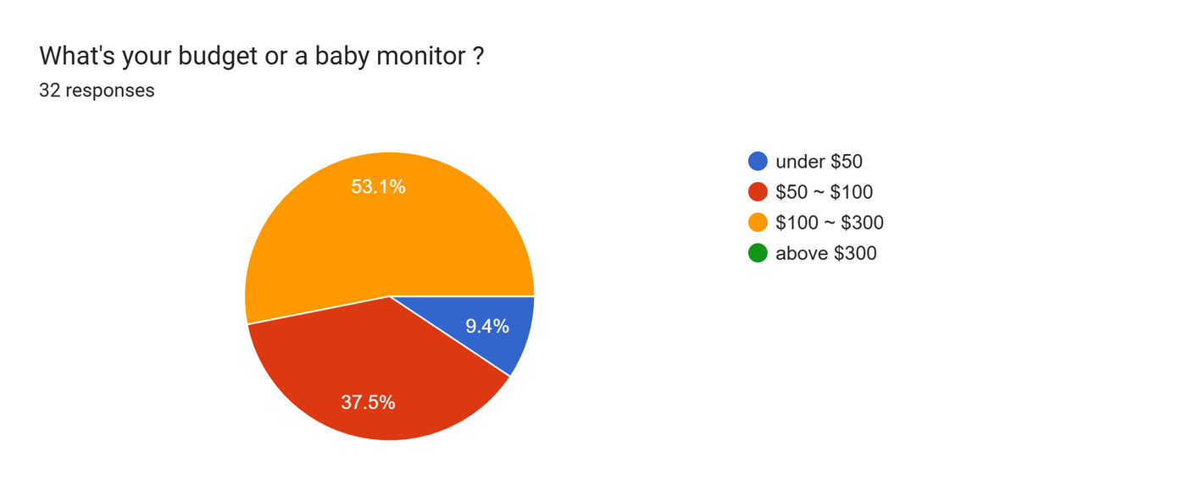
Fig. A6. Budget

Appendix B: Technical Engineering Standards
- ISO 10993-1:2025- Biological Evaluation of Medical Devices:
- This standard focuses on the safety of the materials that will be in direct physical contact with a user. The standard also helps to identify, assess, and manage any risks that come from your design and materials.
- IEEE. 2700-2017 – IEEE Standard for Sensor Performance Parameter Definitions
- This standard deals with various different sensors and their performance. These performance parameters are included with all industry accepted performance parameters.
- ISO 5725-1:2023- Accuracy (trueness and precision) of Measurement Methods and Results
- This standard provides definitions and methods of determining the accuracy of a measurement method and its results. Accuracy is defined as the trueness and precision of the results.
- IEEE Draft Recommended Practice for General Principles for Temperature Limits in The Rating of Electrical Equipment and for the Evaluation of Electrical Insulation
- This is an active-draft standard that focuses on controlling temperature limits for an electrical insulating device.
- ASTM E2516-11 – Standard Classification for Cost Estimate Classification System
- This standard provides a method to estimate and classify costs for any system in any industry. Improved organization and classification of costs will assist to avoid bad business decisions
- 802.11-2024 – IEEE Standard for Information Technology—Telecommunications and Information Exchange Between Systems Local and Metropolitan Area Networks—Specific Requirements Part 11: Wireless LAN Medium Access Control (MAC) and Physical Layer (PHY) Specifications
- This standard is the basis for wireless local area networks. This provides wireless connectivity to fixed, portable, or moving stations.
- IEC. 62133-2:2017 – Secondary Cells and Batteries Containing Alkaline or Other Non-Acid Electrolytes
- This standard involves the safety of rechargeable lithium-ion batteries. This covers not only the safety of these batteries, but also the performance.

Appendix C: Concept Map
Table C-I: General Concept Map
Sensors | Micro-Controller | Sleep Position Sensing | Battery/Power | App Development Environment
Combined Heart rate and o2 Sensor (MAX30102) | ESP32 | Camera: ESP32-CAM | 5V Lithium Ion [microcontroller] | Firebase
Integrated Circuit Temperature Sensor (AS6223, AS6221-AWLT-S) | Arduino | OV7670 Camera [Arduino] | 6V Polymer Lithium Ion [microcontroller] | Wix
Electrochemical o2 sensor: I2C | STM | IFO IV7670 Camera [STM32] | 120V outlet [camera] | Base44
Heart rate Sensor (sen-11574) | PIC16F877A | Gyroscope | 3V CR2032 Rechargeable Battery Coin | Adalo
 | HiLetgo ESP32 mini | Pressure Sensor | 5V USB [microcontroller] | Flutter

Table C-II: Design Alternative I-Combined Sensor
Sensors | Micro-Controller | Sleep Position Sensing | Battery/Power | App Development Environment
Combined Heart rate and o2 Sensor (MAX30102) | TinyPICO ESP32 | ESP32 S3 Sense | 5V Lithium Ion | Base44

Table C-III: Design Alternative II- Separate Sensor
Sensors | Micro-Controller | Sleep Position Sensing | Battery/Power | App Development Environment
Integrated Circuit Temperature Sensor (AS6223, AS6221-AWLT-S) | TinyPICO ESP32 | Camera: ESP32-CAM | 5V Lithium Ion [microcontroller] | Firebase
Electrochemical o2 sensor: I2C
Heart rate Sensor (sen-11574)

Table C-IV: Design Alternative III- Camera Elimination
Sensors | Micro-Controller | Sleep Position Sensing | Battery/Power | App Development Environment
Integrated Circuit Temperature Sensor (AS6223, AS6221-AWLT-S) | TinyPICO ESP32 | Gyroscope | 5V Lithium Ion | Base44
Combined Heart rate and o2 Sensor (MAX30102)

Appendix D: Decision Matrix Pairwise Comparisons
Table D-I: Individual Pairwise Comparisons
Dominik | Criteria 2 | Criteria 3 | Criteria 9 | Criteria 11 | Geometric Mean | Weights
Criteria 2 | 1 | 1/3 | 1/3 | 1/4 | 0.41 | 0.09
Criteria 3 | 3 | 1 | 3 | 1 | 1.73 | 0.37
Criteria 9 | 3 | 1/3 | 1 | 1/2 | 0.84 | 0.18
Criteria 11 | 4 | 1 | 2 | 1 | 1.68 | 0.36
 |  |  |  |  |  | 1.00

Alfonso | Criteria 2 | Criteria 3 | Criteria 9 | Criteria 11 | Geometric Mean | Weights
Criteria 2 | 1 | 3 | 1/3 | 1/3 | 1.32 | 0.10
Criteria 3 | 1/3 | 1 | 7 | 9 | 4.58 | 0.30
Criteria 9 | 3 | 1/7 | 1 | 1 | 1.32 | 0.29
Criteria 11 | 3 | 1/9 | 1 | 1 | 1.32 | 0.31
 |  |  |  |  |  | 1.00

Anthonio | Criteria 2 | Criteria 3 | Criteria 9 | Criteria 11 | Geometric Mean | Weights
Criteria 2 | 1 | 2 | 1/5 | 1/5 | 0.53 | 0.11
Criteria 3 | 1/2 | 1 | 1/2 | 1/3 | 0.58 | 0.12
Criteria 9 | 5 | 2 | 1 | 1 | 1.78 | 0.37
Criteria 11 | 5 | 3 | 1 | 1 | 1.97 | 0.41
 |  |  |  |  |  | 1.00

Zhixian | Criteria 2 | Criteria 3 | Criteria 9 | Criteria 11 | Geometric Mean | Weights
Criteria 2 | 1 | 1/5 | 1/5 | 1/3 | 0.34 | 0.07
Criteria 3 | 5 | 1 | 3 | 1 | 1.97 | 0.40
Criteria 9 | 5 | 1/3 | 1 | 5 | 1.70 | 0.35
Criteria 11 | 3 | 1 | 1/5 | 1 | 0.88 | 0.18
 |  |  |  |  |  | 1.00

Julian | Criteria 2 | Criteria 3 | Criteria 9 | Criteria 11 | Geometric Mean | Weights
Criteria 2 | 1 | 1/2 | 1/4 | 1/5 | 0.40 | 0.07
Criteria 3 | 2 | 1 | 1/3 | 1/4 | 0.64 | 0.11
Criteria 9 | 4 | 3 | 1 | 2 | 2.21 | 0.38
Criteria 11 | 5 | 4 | 2 | 1 | 2.51 | 0.44
 |  |  |  |  |  | 1.00

Table D-II: Average Weights of Pairwise Comparison
 | Dominik | Alfonso | Anthonio | Zhixian | Julian | Average of Weights
Criteria 2 | 0.09 | 0.10 | 0.11 | 0.07 | 0.07 | 0.10
Criteria 3 | 0.37 | 0.30 | 0.12 | 0.40 | 0.11 | 0.30
Criteria 9 | 0.18 | 0.29 | 0.37 | 0.35 | 0.38 | 0.29
Criteria 11 | 0.36 | 0.31 | 0.41 | 0.18 | 0.44 | 0.31

Table D-III: Rating of Design Alternatives Relative to Criteria
 | Alternative 1 | Alternative 2 | Alternative 3
Criteria 2 | 3 | 3.1 | 4
Criteria 3 | 4.4 | 4.2 | 5
Criteria 9 | 5 | 4.8 | 2.8
Criteria 11 | 3.6 | 3.3 | 4

Table D-IV: Decision Matrix
 |  | Alternative 1 | Alternative 2 | Alternative 3
Criteria 2 | 0.10 | 3 | 3.1 | 4
Criteria 3 | 0.31 | 4.4 | 4.2 | 5
Criteria 9 | 0.29 | 5 | 4.8 | 2.8
Criteria 11 | 0.31 | 3.6 | 3.3 | 4
Score |  | 4.19 | 3.99 | 3.96

Appendix E: Datasheets for Parts
Datasheets of the parts we used:
[1] High-Sensitivity Pulse Oximeter and Heart-Rate Sensor for Wearable Health: MAX30102 Accessed Nov. 30, 2025. [Online] Available: https://safetosleep.nichd.nih.gov/resources/social-digital .
[2] HDC1080 Low Power, High Accuracy Digital Humidity Sensor with Temperature Sensor. Accessed Nov. 30, 2025. [Online] Available: https://safetosleep.nichd.nih.gov/resources/social-digital .
[3] ESP32-PICO Series. Accessed Nov. 30, 2025. [Online] Available: https://documentation.espressif.com/esp32-pico_series_datasheet_en.pdf.
[4] ESP32-S3 Series. Accessed Nov. 30, 2025. [Online] Available: https://documentation.espressif.com/esp32-s3_datasheet_en.pdf.
[4] OV2640FSL Color CMOS 2.0 MegaPixel Camera Module with OmniPixel2TM Technology. Accessed Nov. 30, 2025. [Online] Available: https://www.mpja.com/download/ov2640data%20sheet.pdf .

Appendix F: User Manual
Camera Module
Mount the Camera module suspended above the baby's sleeping area, having the entire sleeping area in view of the camera. Make sure the Camera is 19-25 inches directly above the baby. After securing mounting, make sure to plug in the module into a power outlet, and then plugging into the module via USB-C. A red LED on the camera module will light up once powered. If correctly connected, it will display the live sensor readings and body position.
WI-FI Setup
To setup your device:
- Make sure you have powered on the camera system
- Open the Wi-Fi settings on any device of your choosing and connect to the network called BabyMonitor-Setup
- Once connected to the Baby-Monitor-setup, open your browser and enter the IP address: 192.168.4.1 into the search bar
- Once you enter the IP address into the search bar, a website will display prompting your Wi-Fi credentials. Enter your local Wi-Fi network information for your Little Guardian to connect to
Once this has been completed, your Wi-Fi credentials should be saved, and a page will appear confirming this. On screen will also be shown the URL to the locally hosted webpage which will display all the information from your monitoring device. Be sure to reconnect your device to your local Wi-Fi network before entering the URL. Once reconnected to your local Wi-Fi network, place the little guardian URL into the search bar and your monitoring dashboard should appear.

Appendix G: Lessons Learned
Anthonio Torres: I think one of the biggest lessons I learned is that time management is key and there is no real shortcuts. The team attempted to take shortcuts while building, however it proved to work against us. As usually, we would have to go back and do something the right way anyways. In terms of time management, this was the most difficult part in my opinion. As students, we have various classes and exams, as well as team members having responsibilities outside of school. This gave us very little time to coordinate and organize, which stunted our progress throughout the semester. So, coordinating together and managing our time is everything.
Julian Pelayo: Learning KiCad was the biggest lesson I learned. This is because I started with no knowledge on how to design a PCB and arrange the parts on a board. I also originally had stage freight, though with multiple presentations I began to become more confident. I learned how to better talk to others, which helped me greatly during EXPO. I also gained experience when it came to working with a team. Sharing ideas and researching our product showed me how to better research the market.
Dominik Kornak: Senior Design was an interesting experience where I learned how to work as a team on a distinct project and follow criteria and deadlines that prepared me for the real world. I also got the experience of working on a project from the conceptual aspect to the final implementations, learning the whole design process along the way. I learned how to setup and connect microcontrollers to Wi-Fi networks and host webpages on them, improving my knowledge in the wireless communication field.
Alfonso Naula: Designing the PCB was the biggest challenge I faced and the biggest learning experience I had. I had no previous experience working with KiCad, so it was a new challenge. I implemented our Wearable design, and porved it was a working prototype. I also learned how to work with a group in a more efficient way, developing a project form start to finish.
Zhixian Yin: Through the development and testing of the wearable bracelet, I learned that sensor placement and signal quality are very important for accurate readings. Even though the MAX30102 sensor can measure heart rate and SpO₂, the readings can be affected by movement, loose contact, and unstable positioning on the wrist. This taught me the importance of mechanical design, not only the electronic circuit. I also learned that validating our system against a reference device, such as a smartwatch, is necessary to evaluate accuracy. Finally, I learned that a working product must balance many factors, and the engineer designing the product may not be able to aware of all factors. These lessons helped me better understand the challenges of designing a practical system.

Appendix H: Task Allocation and Timeline
This section outlines a week-by-week plan for the 2026 spring semester; including tasks and goals that need to be reached on a week-by-week basis. The timeline also includes teammates' lead for their specific tasks.
Table H-I: Task Allocation and Timeline for Spring 2026
Spring 2026 | Task Accomplished | Teammate Contribution
Week 1 | 1. Have a full layout of all parts, sensors, battery pack, and microcontroller with silicon wearable  2. Setup Camera with ESP32-s3 and train network with dataset. | 1.Zhixian in charge of layout of all parts, Julian and Alfonso assisting with battery and sensors.  2.Dominik in charge of setting up camera and training dataset; Anthonio assisting.
Week 2 | 1.Connect all sensors and battery to microcontroller and place inside wearable; making necessary changes to wearable construction  2. Optimization of trained network; pruning, quantization, making sure it fits comfortably into ESP-32-s3 memory size | 1. Zhixian in charge of connection of all parts  2.Julian and Alfonso in charge of fitment of sensors, battery, mc, into wearable.  3. Dominik in charge of setting up camera and training dataset; Anthonio assisting.
Week 3 | 1. Write the sensor configuration code in C, have the 3 sensor outputs ready to be sent to the app.  2. Deploy network onto ESP-32-s3, start writing inference pipeline in C for ESP32.  3. Figuring out Bluetooth/Wi-Fi communication between ESP’s and app | 1. Zhixian in charge of writing sensor configuration code in C and Alfonso assisting  2. Dominik in charge of writing inference pipeline.  3. Anthonio in charge of starting app development, mainly focusing on communication between ESP and app and Julian assisting.
Week 4 | 1. Finalize all sensor code and write communication code between ESP and app  2. Have most of the C code written, also write same communication code between ESP and app  3. Finalize communication protocols and help ESP code communicate to app. | 1. Zhixian in charge of writing sensor configuration code in C and Alfonso assisting  2. Dominik in charge of writing inference pipeline.  3. Anthonio in charge of finalizing communication between ESP and app and Julian assisting.
Week 5 | 1.Finalize all wearable device esp deployment and begin testing vital readings.  2. Finalize inference pipeline, get camera to input data into inference pipeline  3. Start a general UI display for app | 1. Zhixian in charge of finalizing sensor configuration code and Alfonso in charge of testing (test on himself to display heartrate and body temperature 02 level and use another device to compare readings)  2. Dominik in charge of finalizing inference pipeline and configuring input image data  3. Anthonio in charge of starting app design and Julian assisting
Week 6 | 1. Continue testing wearable, make changes as necessary  2. Finalize all inference with input camera image, begin testing.  3. Continue app design working on displaying signals | 1. Zhixian in charge of editing sensor configuration code and Alfonso in charge of testing  2. Dominik in charge of finalizing all inference and beginning testing with Julian assisting (use a baby doll in different positions to detect position)  3. Anthonio in charge of continuing app design focusing on signal display and Julian assisting
Week 7 | 1. Continue testing wearable, make changes as necessary  2. Continue testing camera inference, making changes as necessary  3. Continue app design finishing signal display working on notification for infant position | 1. Zhixian in charge of editing sensor configuration code and Alfonso in charge of testing  2. Dominik in charge of testing and editing code with Julian assisting  3. Anthonio in charge of continuing app design focusing on notifications and Julian assisting
Week 8 | 1. Finalize testing and have working wearable device  2. Continue testing camera inference, making changes as necessary  3. Continue app design finalizing on notification for infant position | 1. Zhixian in charge of finalizing wearable device with Alfonso assisting  2. Dominik in charge of testing and editing code with Julian assisting  3. Anthonio in charge of continuing app design finalizing notifications and Julian assisting
Week 9 | 1. Continue testing camera inference, making changes as necessary  2. Continue app design finishing notification and making final tweaks to app implementation | 1. Dominik in charge of testing and editing code with Julian and Zhixian assisting  2. Anthonio in charge of continuing app design making final tweaks and Alfonso assisting
Week 10 | 1.Finalize inference with esp32 and camera  2.Finalize app implementation, make it deployable, downloadable | 1. Dominik in charge of finalizing inference on esp32 with camera and Julian and Zhixian assisting  2. Anthonio in charge of finalizing app design with Alfonso assisting
Week 11 | 1. Begin final report and poster | 1. No team lead; each person writing report on their respective sections and beginning poster design
Week 12 | 1. Continue working on final report and poster | 1. No team lead; each person writing report on their respective sections and beginning poster design
Week 13 | 1. Finalize report and poster; prepare presentation about project | 1. No team lead; each person writing report on their respective sections and continuing poster design
Week 14 | 1. Submit poster and report April 14. Finalize presentation | 1. No team lead; finalize report and poster. Also discuss presentation roles and practice respective presentation information
Week 15 | 1.Finalize any loose pieces in presentation. EXPO Friday | 1.No team lead; All teammates contribute to presentation equally

Appendix I: Images of Final prototype and UI
Figure H-I: Wearable Device Final Prototype
Figure H-II: Camera Device and Mount Final Prototype
Figure H-III: Webpage UI Design

Appendix J: Testing Sheets
Table J-I: Acceptance Test #1: Machine Learning Accuracy
Test Writer: Anthonio Torres
Test Case Name: |  | Acceptance Test #1: Machine Learning Accuracy |  |  |  |  | Test ID #:
Description: |  | Checks the engineering requirement: The camera must detect if the infant is laying on their stomach, back or side with an accuracy of 75% using the system setup details provided in the manual |  |  |  |  | Type: | ☑ white box
 |  |  |  |  |  |  |  | ☐ black box
Tester Information
Name of Tester: |  | Dominik Kornak |  |  |  |  | Date: | 4/22/26
Hardware Version |  | Final Camera Prototype |  |  |  |  | Time: | 11:11am
Set up: |  |  | Test must be performed within 200 feet of a local Wi-Fi network
Step | Action |  | Expected Result | Pass | Fail | N/A | Comments
1 | Power on the camera system and complete Wi-Fi and crib arm setup |  | Camera system should begin a local hotspot to allow a local Wi-Fi connection to be established with the camera. Then webpage should be visible with live feed from camera | ☑
2 | Place a baby doll in the crib on its stomach 10 times and record resulting predictions |  | The machine learning should predict at least 8 out of 10 stomach positions correctly to meet the 75% accuracy | ☑
3 | Place a baby doll in the crib on its back 10 times and record resulting predictions |  | The machine learning should predict at least 8 out of 10 back positions correctly to meet the 75% accuracy | ☑
4 | Place a baby doll in the crib on its side 10 times and record resulting predictions |  | The machine learning should predict at least 8 out of 10 side positions correctly to meet the 75% accuracy | ☑
Overall test result: |  |  |  | ☑
Table J-II: Acceptance Test #2: Temperature Shutoff
Test Writer: Anthonio Torres
Test Case Name: |  | Acceptance Test #2: Temperature Shutoff |  |  |  |  | Test ID #:
Description: |  | Checks the engineering requirement: The device should auto shutoff if device internal temperature reaches a temperature of 108F |  |  |  |  | Type: | ☑ white box
 |  |  |  |  |  |  |  | ☐ black box
Tester Information
Name of Tester: |  | Anthonio Torres |  |  |  |  | Date: | 4/5/26
Hardware Version |  | Perfboard Prototype |  |  |  |  | Time: | 3:26pm
Set up: |  |  | Obtain a heat gun to be used in this test
Step | Action |  | Expected Result | Pass | Fail | N/A | Comments
1 | Power on the wearable device and allow system to initialize |  | Wearable device should be on, which should be indicated by the red light of the Max sensor being on | ☑
2 | Monitor the wearable device on VSCode and view wearable periodic readings |  | Terminal should output health biometric readings periodically. The terminal will also print the internal device temperature periodically | ☑
3 | Apply heat to the wearable prototype with a heat gun, at least 6 inches away |  | Periodic print statements for the internal temperature should show increasing temperature. Once a reading above 108F is reached, the device should enter deep sleep and halt operation | ☑
Overall test result: |  |  |  | ☑
Table J-III: Acceptance Test #3: Temperature Reading
Test Writer: Anthonio Torres
Test Case Name: |  | Acceptance Test #3: Temperature Reading |  |  |  |  | Test ID #:
Description: |  | Checks the engineering requirement: The sensors must detect body temperature with 95% accuracy or more |  |  |  |  | Type: | ☑white box
 |  |  |  |  |  |  |  | ☐ black box
Tester Information
Name of Tester: |  | Anthonio Torres |  |  |  |  | Date: | 4/15/26
Hardware Version |  | Perfboard Prototype |  |  |  |  | Time: | 2:40pm
Set up: |  |  | Obtain a digital thermometer for this test
Step | Action |  | Expected Result | Pass | Fail | N/A | Comments
1 | Power on the wearable device and allow system to initialize |  | Wearable device should be on, which should be indicated by the red light of the Max sensor being on | ☑
2 | Monitor the wearable device on VSCode and view wearables periodic readings |  | Terminal should output health biometric readings periodically for the heart rate, blood oxygen and body temperature values | ☑
3 | Place both the wearable sensor and a digital thermometer against ankle and record body temperature samples |  | A minimum of 30 samples should be recorded from the wearable and thermometer, at the same time points | ☑
4 | Place the data in a table and plot. Calculate the mean absolute percentage error |  | Plot of body temperature values from both references should have a percent error less than 5%. The mean absolute percentage error should be below 5%, indicating the accuracy is above 95% | ☑
Overall test result: |  |  |  | ☑
Table J-IV: Acceptance Test #4: Blood Oxygen Reading
Test Writer: Anthonio Torres
Test Case Name: |  | Acceptance Test #4: Blood Oxygen Reading |  |  |  |  | Test ID #:
Description: |  | Checks the engineering requirement: The sensors must detect blood oxygen with 95% accuracy or more |  |  |  |  | Type: | ☐white box
 |  |  |  |  |  |  |  | ☑ black box
Tester Information
Name of Tester: |  | Zhixian Yin |  |  |  |  | Date: | 4/10/26
Hardware Version |  | Breadboard Prototype |  |  |  |  | Time: | 5:00pm
Set up: |  |  | Obtain an Apple Watch and wear on wrist to collect data in this test
Step | Action |  | Expected Result | Pass | Fail | N/A | Comments
1 | Power on the wearable device and allow system to initialize |  | Wearable device should be on, which should be indicated by the red light of the Max sensor being on | ☑
2 | Monitor the wearable device on VSCode and view wearables periodic readings |  | Terminal should output health biometric readings periodically for the heart rate, blood oxygen and body temperature values | ☑
3 | Place finger on wearable sensor to record periodic O2 readings along with Apple Watch O2 readings |  | A minimum of 10 O2 samples should be recorded from the wearable and thermometer, at the same time points | ☑
4 | Place the data in a table and plot. Calculate the mean absolute percentage error |  | Plot of blood oxygen values should have a percent error less than 5%. The mean absolute percentage error should be below 5%, indicating the accuracy is above 95% | ☑
Overall test result: |  |  |  | ☑
Table J-V: Acceptance Test #5: Heart Rate Accuracy
Test Writer: Anthonio Torres
Test Case Name: |  | Acceptance Test #5: Heart Rate Accuracy |  |  |  |  | Test ID #:
Description: |  | Checks the engineering requirement: The sensor must detect heart rate with 95% accuracy or more |  |  |  |  | Type: | ☐white box
 |  |  |  |  |  |  |  | ☑ black box
Tester Information
Name of Tester: |  | Zhixian Yin |  |  |  |  | Date: | 4/10/26
Hardware Version |  | Breadboard Prototype |  |  |  |  | Time: | 5:00pm
Set up: |  |  | Obtain an Apple Watch and wear on wrist to collect data in this test
Step | Action |  | Expected Result | Pass | Fail | N/A | Comments
1 | Power on the wearable device and allow system to initialize |  | Wearable device should be on, which should be indicated by the red light of the Max sensor being on | ☑
2 | Monitor the wearable device on VSCode and view wearables periodic readings |  | Terminal should output health biometric readings periodically for the heart rate, blood oxygen and body temperature values | ☑
3 | Place finger on wearable sensor to record periodic heart rate readings along with Apple Watch O2 readings |  | A minimum of 10 heart rate samples should be recorded from the wearable and thermometer, at the same time points | ☑
4 | Place the data in a table and plot. Calculate the mean absolute percentage error |  | Plot of heart rate values should have a percent error less than 5%. The mean absolute percentage error should be below 5%, indicating the accuracy is above 95% | ☑
Overall test result: |  |  |  | ☑
Table J-VI: Acceptance Test #6: Webpage Range of Connection
Test Writer: Anthonio Torres
Test Case Name: |  | Acceptance Test #6: Webpage Range of Connection |  |  |  |  | Test ID #:
Description: |  | Checks the engineering requirement: The wireless connection should have at least 200 feet of range in open space (no walls/obstruction) |  |  |  |  | Type: | ☑white box
 |  |  |  |  |  |  |  | ☐ black box
Tester Information
Name of Tester: |  |  |  |  |  |  | Date:
Hardware Version |  |  |  |  |  |  | Time:
Set up: |  |  | Requires access to a reliable Wi-Fi network in an open space of at least 200 feet
Step | Action |  | Expected Result | Pass | Fail | N/A | Comments
1 | Power on the camera system and complete Wi-Fi and crib arm setup |  | Camera system should begin a local hotspot to allow a local Wi-Fi connection to be established with the camera. Then webpage should be visible with live feed from camera |  |  | ☑
2 | Stand by the crib and camera, then walk away until the webpage disconnects. Refresh the page every 50 feet |  | The webpage should remain accessible from a distance of 200 feet. This means the webpage should be able to reload after refreshing 4 times. |  |  | ☑
Overall test result: |  |  |  |  |  | ☑
Table J-VII: Acceptance Test #7: Battery Life
Test Writer: Anthonio Torres
Test Case Name: |  | Acceptance Test #7: Battery Life |  |  |  |  | Test ID #:
Description: |  | Checks the engineering requirement: The wearable device should have a battery life of at least 12 hours |  |  |  |  | Type: | ☑ white box
 |  |  |  |  |  |  |  | ☐ black box
Tester Information
Name of Tester: |  |  |  |  |  |  | Date:
Hardware Version |  | Final PCB Integrated Wearable |  |  |  |  | Time:
Set up: |  |  | Wearable device should be fully charged before beginning test
Step | Action |  | Expected Result | Pass | Fail | N/A | Comments
1 | Power on the camera system and complete Wi-Fi and crib arm setup |  | Camera system should begin a local hotspot to allow a local Wi-Fi connection to be established with the camera. Then webpage should be visible with live feed from camera |  |  | ☑
2 | Reset the wearable device near the camera and allow system to initialize |  | Wearable device should be on, which should be indicated by the red light of the Max sensor being lit. The wearable device data readings should begin to appear on the webpage |  |  | ☑
3 | Allow the system to run, and verify operation of the wearable device every 30 minutes |  | The wearable device should have enough battery life to successfully operate for a minimum of 12 hours |  |  | ☑
Overall test result: |  |  |  |  |  | ☑

